**Requirement Gathering and Analysis Phase**

**Data Flow Diagram &User Stories**

|  |  |
| --- | --- |
| Date | 06-07-2024 |
| Team ID | SWTID1720074953 |
| Project Name | SB foods-Food Ordering app |
| Maximum Marks |  |

**Data Flow Diagrams:**

A Data Flow Diagram (DFD) is a traditional visual representation of the information flows within a system. A neat and clear DFD can depict the right amount of the system requirement graphically. It shows how data enters and leaves the system, what changes the information, and where data is stored.

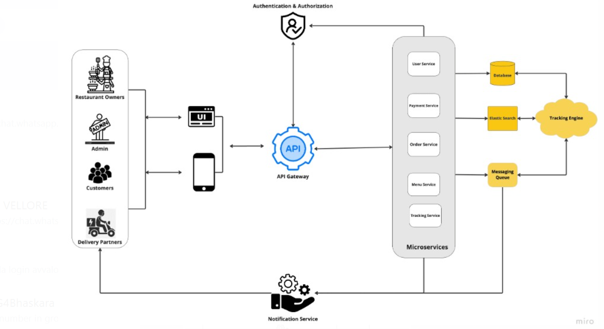

**User → [User Authentication] → User Data Store**

**User → [Browsing and Ordering Food] → Food Items Data Store**

**User → [Cart Management] → Cart**

**User → [Checkout and Payment] → Payment Gateway → Order Data Store**

**Admin → [Order Management] → Order Data Store**

**Customer Care Executive → [Customer Support] → Inquiry Data Store**

**User Stories**

Use the below template to list all the user stories for the product.

| **User Type** | **Functional Requirement (Epic)** | **User Story Number** | **User Story / Task** | **Acceptance criteria** | **Priority** | **Release** |
| --- | --- | --- | --- | --- | --- | --- |
| **Customer (Mobile user)** | Registration | USN-1 | As a user, I can register for the application by entering my email, password, and confirming my password. | I can access my account / dashboard | High | Sprint-1 |
|  |  | USN-2 | As a user, I will receive confirmation email once I have registered for the application | I can receive confirmation email & click confirm | High | Sprint-1 |
|  |  | USN-3 | As a user, I can register for the application through Facebook | I can register & access the dashboard with Facebook Login | Low | Sprint-2 |
|  |  | USN-4 | As a user, I can register for the application through Gmail |  | Medium | Sprint-1 |
|  | Login | USN-5 | As a user, I can log into the application by entering email & password |  | High | Sprint-1 |
|  | Dashboard | USN-6 | As a user, I can view a list of food items on the homepage. | I can see all available food items. | High | Sprint-1 |
| **Customer (Web user)** | Registration | USN-7 | As a web user, I can register for the application by entering my email, password, and confirming my password. | I can access my account/dashboard. | High | Sprint-1 |
|  | Login | USN-8 | As a web user, I will receive a confirmation email once I have registered for the application. | I can access my account/dashboard. | High | Sprint-1 |
|  | Food Ordering | USN-9 | As a user, I can add food items to my cart. | I can see the items in my cart with updated quantities. | High | Sprint-1 |
|  |  | USN-10 | As a user, I can proceed to checkout and enter delivery information. | I can provide my address and proceed to the payment page. | High | Sprint-1 |

|  |  |  |  |  |  |  |
| --- | --- | --- | --- | --- | --- | --- |
|  |  | USN-11 | As a user, I can make a payment using the integrated payment gateway. | I can complete the payment and see my order confirmation. | High | Sprint-1 |
|  |  | USN-12 | As a user, I can view my order status on the order details page. | I can see the current status of my order (e.g., processing, out for delivery, delivered). | High | Sprint-1 |
| **Customer Care Executive** | Order Management | USN-13 | As a customer care executive, I can update the status of support tickets. | I can change the status of a support ticket to resolved, pending, or in progress. | High | Sprint-1 |
|  |  | USN-14 | As a customer care executive, I can view the details of customer orders to assist with inquiries. | I can see order details including product name, quantity, price, and delivery status. | Medium | Sprint-1 |
| **Administrator** | Order Management | USN-15 | As an admin, I can view all the orders placed by users. | I can see the list of orders with details like product name, quantity, price, and delivery address. | High | Sprint-1 |
|  |  | USN-16 | As an admin, I can update the status of an order. | I can change the order status to processing, out for delivery, or delivered. | High | Sprint-1 |
|  | Inventory Management | USN-17 | As an admin, I can add new food items to the inventory. | I can add a new food item with details like name, description, category, price, and image. | High | Sprint-1 |
|  |  | USN-18 | As an admin, I can delete existing food items from the inventory. | I can remove a food item from the list, and it should no longer be available on the website. | Medium | Sprint-1 |